df

Autogenerated data summary from dataMaid

2021-09-18 03:31:38

# Data report overview

The dataset examined has the following dimensions:

|  |  |
| --- | --- |
| Feature | Result |
| Number of observations | 569 |
| Number of variables | 33 |

### Checks performed

The following variable checks were performed, depending on the data type of each variable:

|  |  |  |  |  |  |  |  |  |
| --- | --- | --- | --- | --- | --- | --- | --- | --- |
|  | character | factor | labelled | haven labelled | numeric | integer | logical | Date |
| Identify miscoded missing values | × | × | × | × | × | × |  | × |
| Identify prefixed and suffixed whitespace | × | × | × | × |  |  |  |  |
| Identify levels with < 6 obs. | × | × | × | × |  |  |  |  |
| Identify case issues | × | × | × | × |  |  |  |  |
| Identify misclassified numeric or integer variables | × | × | × | × |  |  |  |  |
| Identify outliers |  |  |  |  | × | × |  | × |

Please note that all numerical values in the following have been rounded to 2 decimals.

# Summary table

|  |  |  |  |  |
| --- | --- | --- | --- | --- |
|  | Variable class | # unique values | Missing observations | Any problems? |
| id | integer | 569 | 0.00 % | × |
| diagnosis | character | 2 | 0.00 % |  |
| radius_mean | numeric | 456 | 0.00 % | × |
| texture_mean | numeric | 479 | 0.00 % | × |
| perimeter_mean | numeric | 522 | 0.00 % | × |
| area_mean | numeric | 539 | 0.00 % | × |
| smoothness_mean | numeric | 474 | 0.00 % | × |
| compactness_mean | numeric | 537 | 0.00 % | × |
| concavity_mean | numeric | 537 | 0.00 % |  |
| concave.points_mean | numeric | 542 | 0.00 % | × |
| symmetry_mean | numeric | 432 | 0.00 % | × |
| fractal_dimension_mean | numeric | 499 | 0.00 % | × |
| radius_se | numeric | 540 | 0.00 % | × |
| texture_se | numeric | 519 | 0.00 % | × |
| perimeter_se | numeric | 533 | 0.00 % | × |
| area_se | numeric | 528 | 0.00 % | × |
| smoothness_se | numeric | 547 | 0.00 % | × |
| compactness_se | numeric | 541 | 0.00 % | × |
| concavity_se | numeric | 533 | 0.00 % | × |
| concave.points_se | numeric | 507 | 0.00 % | × |
| symmetry_se | numeric | 498 | 0.00 % | × |
| fractal_dimension_se | numeric | 545 | 0.00 % | × |
| radius_worst | numeric | 457 | 0.00 % | × |
| texture_worst | numeric | 511 | 0.00 % | × |
| perimeter_worst | numeric | 514 | 0.00 % | × |
| area_worst | numeric | 544 | 0.00 % | × |
| smoothness_worst | numeric | 411 | 0.00 % | × |
| compactness_worst | numeric | 529 | 0.00 % | × |
| concavity_worst | numeric | 539 | 0.00 % | × |
| concave.points_worst | numeric | 492 | 0.00 % | × |
| symmetry_worst | numeric | 500 | 0.00 % | × |
| fractal_dimension_worst | numeric | 535 | 0.00 % | × |
| X | logical | 1 | 100.00 % | × |

# Variable list

## id

|  |  |
| --- | --- |
| Feature | Result |
| Variable type | integer |
| Number of missing obs. | 0 (0 %) |
| Number of unique values | 569 |
| Median | 906024 |
| 1st and 3rd quartiles | 869218; 8813129 |
| Min. and max. | 8670; 911320502 |

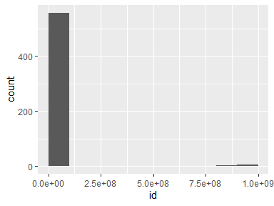

* Note that the following possible outlier values were detected: "8670", "8913", "8915", "9047", "85715", "86208", "86211", "86355", "86408", "86409" (42 additional values omitted).

## diagnosis

|  |  |
| --- | --- |
| Feature | Result |
| Variable type | character |
| Number of missing obs. | 0 (0 %) |
| Number of unique values | 2 |
| Mode | “B” |

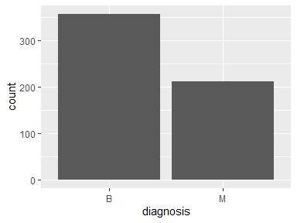

## radius_mean

|  |  |
| --- | --- |
| Feature | Result |
| Variable type | numeric |
| Number of missing obs. | 0 (0 %) |
| Number of unique values | 456 |
| Median | 13.37 |
| 1st and 3rd quartiles | 11.7; 15.78 |
| Min. and max. | 6.98; 28.11 |

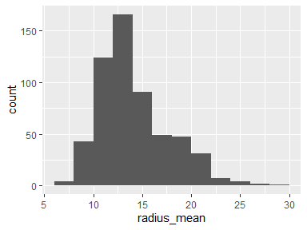

* Note that the following possible outlier values were detected: "6.98", "7.69", "7.73", "7.76", "8.2", "8.22", "8.57", "8.6", "8.6", "8.62" (12 additional values omitted).

## texture_mean

|  |  |
| --- | --- |
| Feature | Result |
| Variable type | numeric |
| Number of missing obs. | 0 (0 %) |
| Number of unique values | 479 |
| Median | 18.84 |
| 1st and 3rd quartiles | 16.17; 21.8 |
| Min. and max. | 9.71; 39.28 |

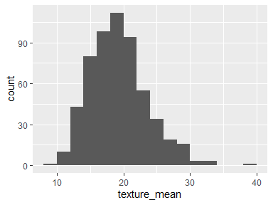

* Note that the following possible outlier values were detected: "9.71", "10.38", "33.56", "33.81", "39.28".

## perimeter_mean

|  |  |
| --- | --- |
| Feature | Result |
| Variable type | numeric |
| Number of missing obs. | 0 (0 %) |
| Number of unique values | 522 |
| Median | 86.24 |
| 1st and 3rd quartiles | 75.17; 104.1 |
| Min. and max. | 43.79; 188.5 |

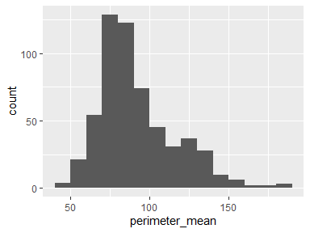

* Note that the following possible outlier values were detected: "43.79", "47.92", "47.98", "48.34", "51.71", "53.27", "54.09", "54.34", "54.42", "54.53" (18 additional values omitted).

## area_mean

|  |  |
| --- | --- |
| Feature | Result |
| Variable type | numeric |
| Number of missing obs. | 0 (0 %) |
| Number of unique values | 539 |
| Median | 551.1 |
| 1st and 3rd quartiles | 420.3; 782.7 |
| Min. and max. | 143.5; 2501 |

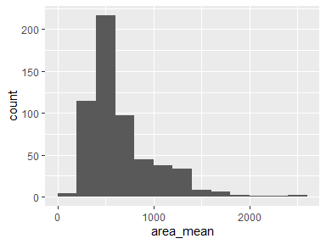

* Note that the following possible outlier values were detected: "143.5", "170.4", "178.8", "181", "201.9", "203.9", "221.2", "221.3", "221.8", "224.5" (21 additional values omitted).

## smoothness_mean

|  |  |
| --- | --- |
| Feature | Result |
| Variable type | numeric |
| Number of missing obs. | 0 (0 %) |
| Number of unique values | 474 |
| Median | 0.1 |
| 1st and 3rd quartiles | 0.09; 0.11 |
| Min. and max. | 0.05; 0.16 |

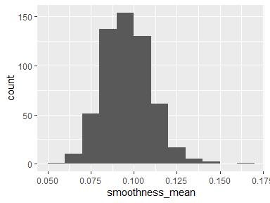

* Note that the following possible outlier values were detected: "0.05", "0.14", "0.14", "0.14", "0.14", "0.16".

## compactness_mean

|  |  |
| --- | --- |
| Feature | Result |
| Variable type | numeric |
| Number of missing obs. | 0 (0 %) |
| Number of unique values | 537 |
| Median | 0.09 |
| 1st and 3rd quartiles | 0.06; 0.13 |
| Min. and max. | 0.02; 0.35 |

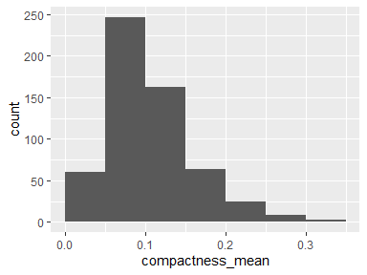

* Note that the following possible outlier values were detected: "0.02", "0.35".

## concavity_mean

|  |  |
| --- | --- |
| Feature | Result |
| Variable type | numeric |
| Number of missing obs. | 0 (0 %) |
| Number of unique values | 537 |
| Median | 0.06 |
| 1st and 3rd quartiles | 0.03; 0.13 |
| Min. and max. | 0; 0.43 |

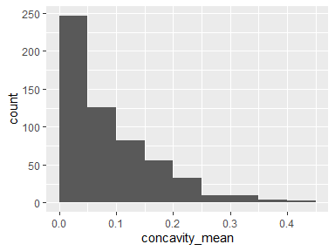

## concave.points_mean

|  |  |
| --- | --- |
| Feature | Result |
| Variable type | numeric |
| Number of missing obs. | 0 (0 %) |
| Number of unique values | 542 |
| Median | 0.03 |
| 1st and 3rd quartiles | 0.02; 0.07 |
| Min. and max. | 0; 0.2 |

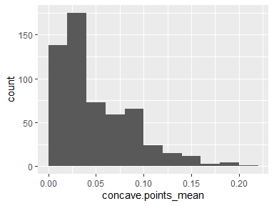

* Note that the following possible outlier values were detected: "0", "0", "0", "0", "0", "0", "0", "0", "0", "0" (26 additional values omitted).

## symmetry_mean

|  |  |
| --- | --- |
| Feature | Result |
| Variable type | numeric |
| Number of missing obs. | 0 (0 %) |
| Number of unique values | 432 |
| Median | 0.18 |
| 1st and 3rd quartiles | 0.16; 0.2 |
| Min. and max. | 0.11; 0.3 |

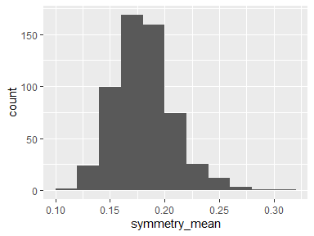

* Note that the following possible outlier values were detected: "0.11", "0.25", "0.25", "0.25", "0.25", "0.26", "0.26", "0.26", "0.26", "0.27" (4 additional values omitted).

## fractal_dimension_mean

|  |  |
| --- | --- |
| Feature | Result |
| Variable type | numeric |
| Number of missing obs. | 0 (0 %) |
| Number of unique values | 499 |
| Median | 0.06 |
| 1st and 3rd quartiles | 0.06; 0.07 |
| Min. and max. | 0.05; 0.1 |

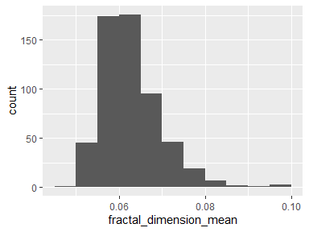

* Note that the following possible outlier values were detected: "0.05", "0.05", "0.05", "0.05", "0.05", "0.05", "0.09", "0.09", "0.1", "0.1" (1 additional values omitted).

## radius_se

|  |  |
| --- | --- |
| Feature | Result |
| Variable type | numeric |
| Number of missing obs. | 0 (0 %) |
| Number of unique values | 540 |
| Median | 0.32 |
| 1st and 3rd quartiles | 0.23; 0.48 |
| Min. and max. | 0.11; 2.87 |

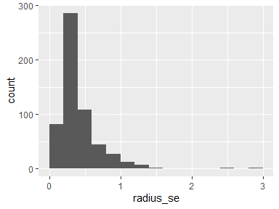

* Note that the following possible outlier values were detected: "0.11", "0.11", "0.12", "0.12", "0.12", "0.12", "0.12", "0.12", "0.13", "1.51" (2 additional values omitted).

## texture_se

|  |  |
| --- | --- |
| Feature | Result |
| Variable type | numeric |
| Number of missing obs. | 0 (0 %) |
| Number of unique values | 519 |
| Median | 1.11 |
| 1st and 3rd quartiles | 0.83; 1.47 |
| Min. and max. | 0.36; 4.88 |

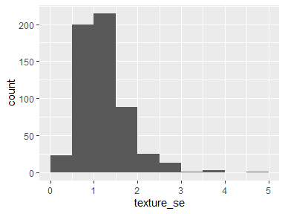

* Note that the following possible outlier values were detected: "0.36", "0.36", "0.36", "3.57", "3.65", "3.9", "4.88".

## perimeter_se

|  |  |
| --- | --- |
| Feature | Result |
| Variable type | numeric |
| Number of missing obs. | 0 (0 %) |
| Number of unique values | 533 |
| Median | 2.29 |
| 1st and 3rd quartiles | 1.61; 3.36 |
| Min. and max. | 0.76; 21.98 |

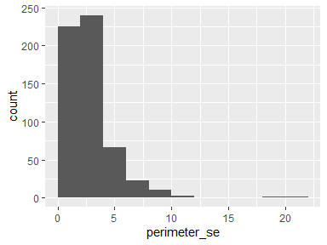

* Note that the following possible outlier values were detected: "0.76", "0.77", "0.84", "0.85", "0.87", "11.07", "18.65", "21.98".

## area_se

|  |  |
| --- | --- |
| Feature | Result |
| Variable type | numeric |
| Number of missing obs. | 0 (0 %) |
| Number of unique values | 528 |
| Median | 24.53 |
| 1st and 3rd quartiles | 17.85; 45.19 |
| Min. and max. | 6.8; 542.2 |

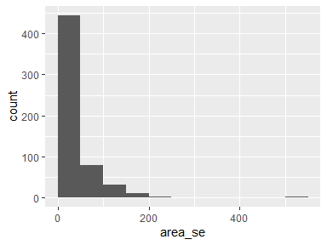

* Note that the following possible outlier values were detected: "6.8", "7.23", "7.25", "7.33", "8.2", "8.32", "8.61", "8.96", "8.97", "9.01" (52 additional values omitted).

## smoothness_se

|  |  |
| --- | --- |
| Feature | Result |
| Variable type | numeric |
| Number of missing obs. | 0 (0 %) |
| Number of unique values | 547 |
| Median | 0.01 |
| 1st and 3rd quartiles | 0.01; 0.01 |
| Min. and max. | 0; 0.03 |

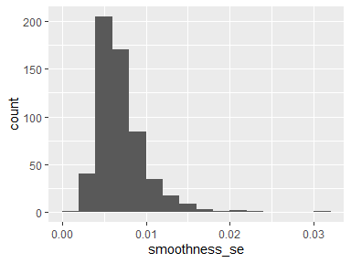

* Note that the following possible outlier values were detected: "0", "0", "0", "0", "0", "0", "0", "0", "0", "0" (10 additional values omitted).

## compactness_se

|  |  |
| --- | --- |
| Feature | Result |
| Variable type | numeric |
| Number of missing obs. | 0 (0 %) |
| Number of unique values | 541 |
| Median | 0.02 |
| 1st and 3rd quartiles | 0.01; 0.03 |
| Min. and max. | 0; 0.14 |

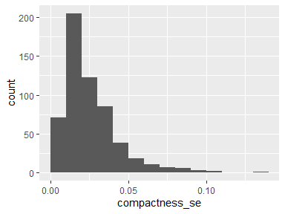

* Note that the following possible outlier values were detected: "0", "0", "0", "0", "0.11", "0.14".

## concavity_se

|  |  |
| --- | --- |
| Feature | Result |
| Variable type | numeric |
| Number of missing obs. | 0 (0 %) |
| Number of unique values | 533 |
| Median | 0.03 |
| 1st and 3rd quartiles | 0.02; 0.04 |
| Min. and max. | 0; 0.4 |

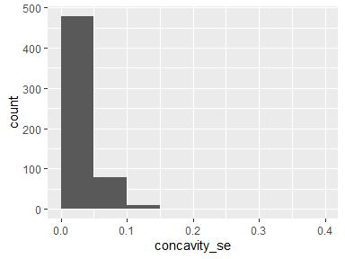

* Note that the following possible outlier values were detected: "0.12", "0.12", "0.13", "0.14", "0.14", "0.15", "0.3", "0.4".

## concave.points_se

|  |  |
| --- | --- |
| Feature | Result |
| Variable type | numeric |
| Number of missing obs. | 0 (0 %) |
| Number of unique values | 507 |
| Median | 0.01 |
| 1st and 3rd quartiles | 0.01; 0.01 |
| Min. and max. | 0; 0.05 |

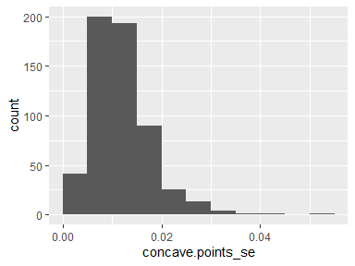

* Note that the following possible outlier values were detected: "0", "0.03", "0.03", "0.03", "0.03", "0.04", "0.04", "0.05".

## symmetry_se

|  |  |
| --- | --- |
| Feature | Result |
| Variable type | numeric |
| Number of missing obs. | 0 (0 %) |
| Number of unique values | 498 |
| Median | 0.02 |
| 1st and 3rd quartiles | 0.02; 0.02 |
| Min. and max. | 0.01; 0.08 |

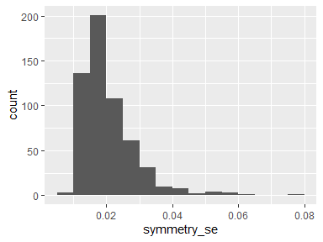

* Note that the following possible outlier values were detected: "0.01", "0.05", "0.05", "0.05", "0.05", "0.05", "0.06", "0.06", "0.06", "0.06" (1 additional values omitted).

## fractal_dimension_se

|  |  |
| --- | --- |
| Feature | Result |
| Variable type | numeric |
| Number of missing obs. | 0 (0 %) |
| Number of unique values | 545 |
| Median | 0 |
| 1st and 3rd quartiles | 0; 0 |
| Min. and max. | 0; 0.03 |

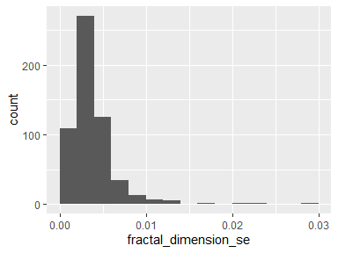

* Note that the following possible outlier values were detected: "0.01", "0.01", "0.01", "0.01", "0.01", "0.01", "0.01", "0.01", "0.01", "0.02" (3 additional values omitted).

## radius_worst

|  |  |
| --- | --- |
| Feature | Result |
| Variable type | numeric |
| Number of missing obs. | 0 (0 %) |
| Number of unique values | 457 |
| Median | 14.97 |
| 1st and 3rd quartiles | 13.01; 18.79 |
| Min. and max. | 7.93; 36.04 |

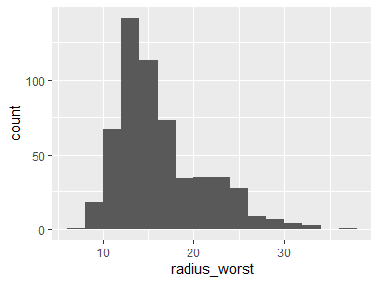

* Note that the following possible outlier values were detected: "7.93", "8.68", "8.95", "8.96", "9.08", "9.09", "9.26", "9.41", "9.46", "9.47" (17 additional values omitted).

## texture_worst

|  |  |
| --- | --- |
| Feature | Result |
| Variable type | numeric |
| Number of missing obs. | 0 (0 %) |
| Number of unique values | 511 |
| Median | 25.41 |
| 1st and 3rd quartiles | 21.08; 29.72 |
| Min. and max. | 12.02; 49.54 |

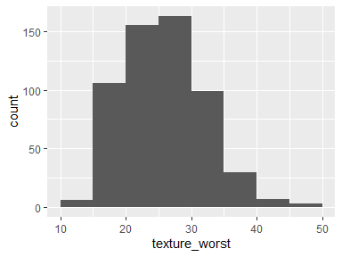

* Note that the following possible outlier values were detected: "44.87", "45.41", "47.16", "49.54".

## perimeter_worst

|  |  |
| --- | --- |
| Feature | Result |
| Variable type | numeric |
| Number of missing obs. | 0 (0 %) |
| Number of unique values | 514 |
| Median | 97.66 |
| 1st and 3rd quartiles | 84.11; 125.4 |
| Min. and max. | 50.41; 251.2 |

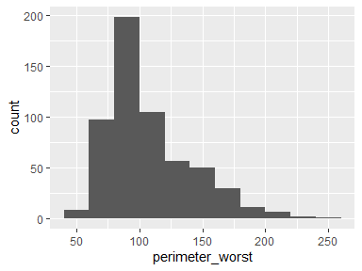

* Note that the following possible outlier values were detected: "50.41", "54.49", "56.65", "57.17", "57.26", "58.08", "58.36", "59.16", "59.9", "60.9" (18 additional values omitted).

## area_worst

|  |  |
| --- | --- |
| Feature | Result |
| Variable type | numeric |
| Number of missing obs. | 0 (0 %) |
| Number of unique values | 544 |
| Median | 686.5 |
| 1st and 3rd quartiles | 515.3; 1084 |
| Min. and max. | 185.2; 4254 |

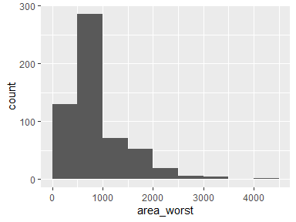

* Note that the following possible outlier values were detected: "185.2", "223.6", "240.1", "242.2", "248", "249.8", "259.2", "268.6", "270", "273.9" (23 additional values omitted).

## smoothness_worst

|  |  |
| --- | --- |
| Feature | Result |
| Variable type | numeric |
| Number of missing obs. | 0 (0 %) |
| Number of unique values | 411 |
| Median | 0.13 |
| 1st and 3rd quartiles | 0.12; 0.15 |
| Min. and max. | 0.07; 0.22 |

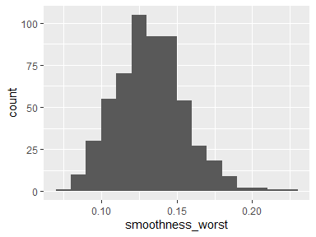

* Note that the following possible outlier values were detected: "0.07", "0.2", "0.21", "0.22", "0.22".

## compactness_worst

|  |  |
| --- | --- |
| Feature | Result |
| Variable type | numeric |
| Number of missing obs. | 0 (0 %) |
| Number of unique values | 529 |
| Median | 0.21 |
| 1st and 3rd quartiles | 0.15; 0.34 |
| Min. and max. | 0.03; 1.06 |

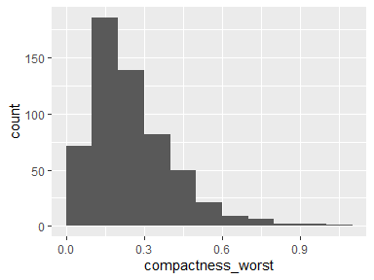

* Note that the following possible outlier values were detected: "0.03", "0.03", "0.04", "0.05", "0.05", "0.05", "0.05", "0.05", "0.05", "0.05" (6 additional values omitted).

## concavity_worst

|  |  |
| --- | --- |
| Feature | Result |
| Variable type | numeric |
| Number of missing obs. | 0 (0 %) |
| Number of unique values | 539 |
| Median | 0.23 |
| 1st and 3rd quartiles | 0.11; 0.38 |
| Min. and max. | 0; 1.25 |

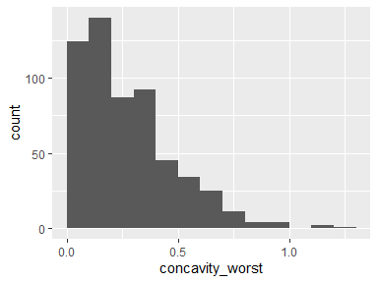

* Note that the following possible outlier values were detected: "1.17", "1.25".

## concave.points_worst

|  |  |
| --- | --- |
| Feature | Result |
| Variable type | numeric |
| Number of missing obs. | 0 (0 %) |
| Number of unique values | 492 |
| Median | 0.1 |
| 1st and 3rd quartiles | 0.06; 0.16 |
| Min. and max. | 0; 0.29 |

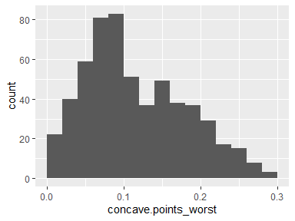

* Note that the following possible outlier values were detected: "0", "0.01", "0.01", "0.01", "0.01", "0.01".

## symmetry_worst

|  |  |
| --- | --- |
| Feature | Result |
| Variable type | numeric |
| Number of missing obs. | 0 (0 %) |
| Number of unique values | 500 |
| Median | 0.28 |
| 1st and 3rd quartiles | 0.25; 0.32 |
| Min. and max. | 0.16; 0.66 |

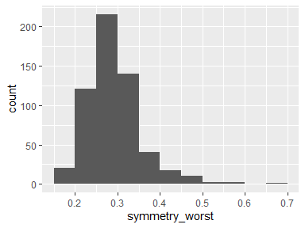

* Note that the following possible outlier values were detected: "0.16", "0.16", "0.16", "0.16", "0.17", "0.17", "0.18", "0.46", "0.47", "0.47" (12 additional values omitted).

## fractal_dimension_worst

|  |  |
| --- | --- |
| Feature | Result |
| Variable type | numeric |
| Number of missing obs. | 0 (0 %) |
| Number of unique values | 535 |
| Median | 0.08 |
| 1st and 3rd quartiles | 0.07; 0.09 |
| Min. and max. | 0.06; 0.21 |

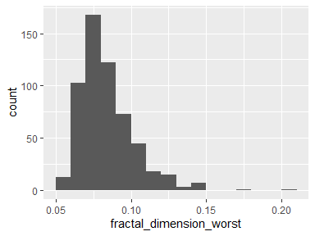

* Note that the following possible outlier values were detected: "0.06", "0.06", "0.06", "0.06", "0.06", "0.17", "0.21".

## X

* The variable only takes one value: "NA".

Report generation information:

* Created by: christopherohit (username: Hendrich).
* Report creation time: Sat Sep 18 2021 03:31:39
* Report was run from directory: C:/Users/Hendrich/Desktop/BTL_Software_Technology/Analysis_Problem_R (Neural Network)/Neural_Network
* dataMaid v1.4.0 [Pkg: 2019-12-10 from CRAN (R 4.0.5)]
* R version 4.0.5 (2021-03-31).
* Platform: x86_64-w64-mingw32/x64 (64-bit)(Windows 10 x64 (build 19042)).
* Function call: makeDataReport(data = df, output = "EDA.Rmd", render = TRUE, replace = TRUE)